Project Design Phase
Solution Architecture

Date | 01 July 2026
Team ID
Project Name | DarshanEase – Temple Darshan Booking System
Maximum Marks | 4 Marks

Solution Architecture:
Solution architecture is a complex process – with many sub-processes – that bridges the gap between business problems and technology solutions. Its goals are to:
- Find the best tech solution to solve existing business problems.
- Describe the structure, characteristics, behavior, and other aspects of the software to project stakeholders.
- Define features, development phases, and solution requirements.
- Provide specifications according to which the solution is defined, managed, and delivered.

Example - Solution Architecture Diagram:

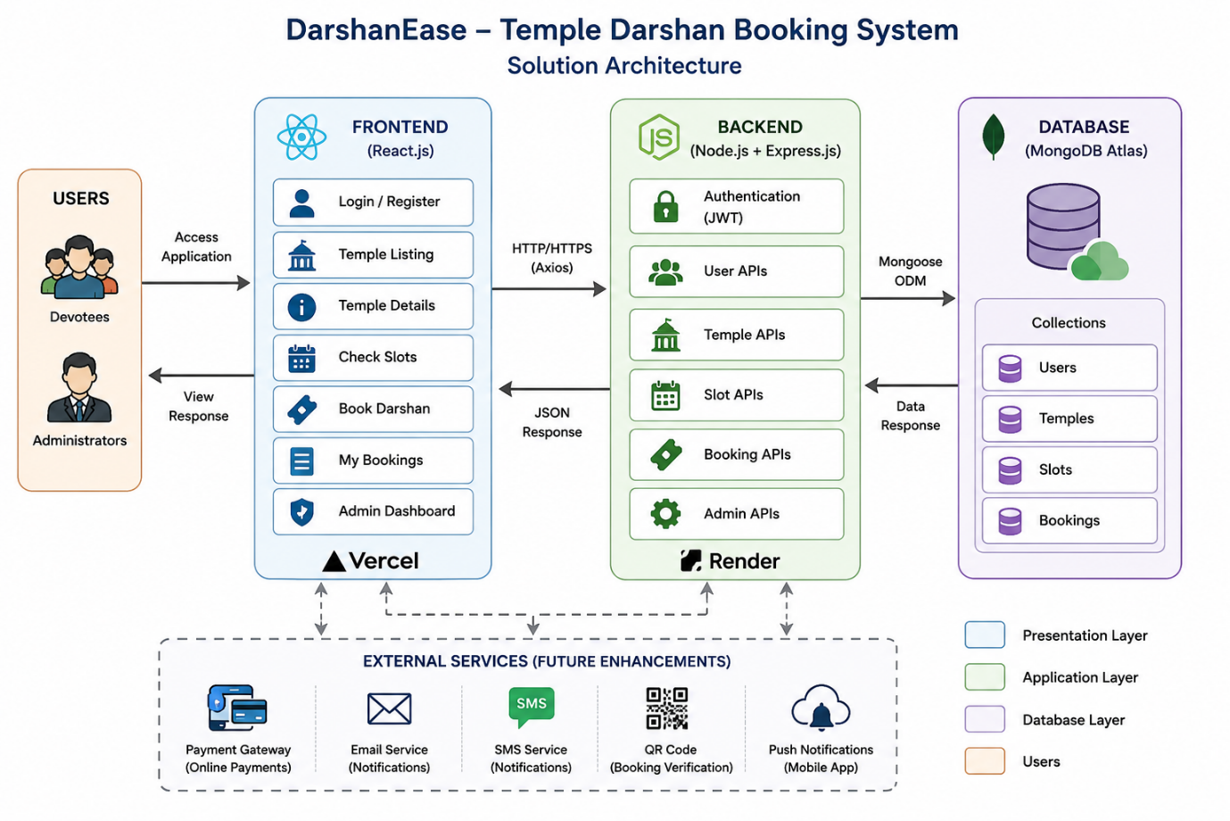
DarshanEase follows a three-tier architecture consisting of the Presentation Layer, Application Layer, and Database Layer.

Presentation Layer:
The frontend is developed using React.js and deployed on Vercel. It provides an interactive user interface for devotees and administrators.

Application Layer:
The backend is developed using Node.js and Express.js and deployed on Render. It processes requests, performs authentication using JWT, executes business logic, and communicates with the database.

Database Layer:
MongoDB Atlas serves as the cloud database. Mongoose is used to interact with collections such as Users, Temples, Slots, and Bookings.

Workflow:
1. The user accesses the React application.
2. Axios sends API requests to the Express backend.
3. The backend authenticates the user using JWT.
4. Business logic is executed.
5. Data is stored and retrieved from MongoDB Atlas.
6. The backend returns JSON responses to the frontend.
7. The frontend displays the results to the user.Reference: https://aws.amazon.com/blogs/industries/voice-applications-in-clinical-research-powered-by-ai-on-aws-part-1-architecture-and-design-considerations/

